# Integrated Mobile Applications Development

# Lab 7 Services

**NOTES**

* When creating an Ionic App for each of the questions in this lab use:

ionic start appName blank

* Controllers should be in controllers.js, not app.js. To do this do the following:
  + If your app is called starter (angular.module('starter',) then the first line of controllers.js should be something like:

angular.module('starter.controllers', [])

* + Now you can write your Controller as normal in controllers.js e.g.

angular.module('starter.controllers', [])

.controller('shoppingListCtrl', function($scope) {

* + Inject the dependency you created in controllers.js ('starter.controllers') into app.js as follows: angular.module('starter', ['ionic', 'starter.controllers'])
  + Add controllers.js to index.html as follows:

<script src="js/controllers.js"></script>

* Services should be in services.js, not app.js. To do this do the following:
  + If your app is called starter (angular.module('starter',) then the first line of services.js should be something like:

angular.module('starter.services', [])

* + Now you can write your Service as normal in services.js e.g.

angular.module('starter.services', [])

.service('ageService', function() {

* + Inject the dependency you created in services.js ('starter.controllers') into app.js as follows: angular.module('starter', ['ionic', 'starter.Controllers', 'starter.services'])
  + Inject the Service you created in services.js ('ageService') into any Controller that will be using the service as follows:

.controller('MainController', function($scope, ageService) {

* + Add services.js to index.html as follows:

<script src="js/services.js"></script>

## Part 1 - Services

1. Write an Ionic Application that asks a user to enter his/her age and has a button that when pressed, will show his/her age next year.

If the age entered is invalid (less than 0, or not a valid integer) the age next year should be shown as ‘??’

The application should use a Service to calculate the age next year.

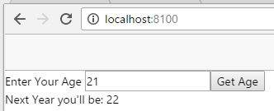

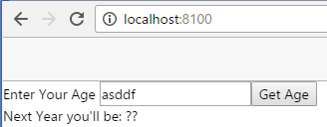

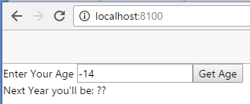

1. Write an Ionic Application consisting of a Controller called StudentController that has only one $scope variable called students.

The StudentController should use the Object Constructor method to create four new students which have the following properties:

|  |  |  |  |
| --- | --- | --- | --- |
|  | Name | Address | DOB |
| Student 1 | Tom | Galway | November 19th 1995 |
| Student 2 | John | Tuam | August 11th 1996 |
| Student 3 | Mary | Ballinasloe | September 1st 1995 |
| Student 4 | Fred | Athenry | August 11th 1994 |

Another Controller called GMITController should have only one $scope variable called GMIT which is an Object (defined using the Object Literal Notation) with the following properties:

|  |  |  |  |
| --- | --- | --- | --- |
|  | Name | Address | Founded |
| GMIT | Galway-Mayo Institute of Technology | Galway, Letterfrack, Mountbellew, Castlebar | September 18th 1972 |

In the View the Students Details should be displayed under the following headings using a [grid](http://ionicframework.com/docs/components/#grid-even):

* + Name
  + Address
  + DOB
  + Age

A separate div element should display details of GMIT as shown, including its age.

The Age should be calculated in a Service called AgeService which returns the current age of whatever is passed to it and both the StudentController and the GMITController should use this service to calculate respective ages.

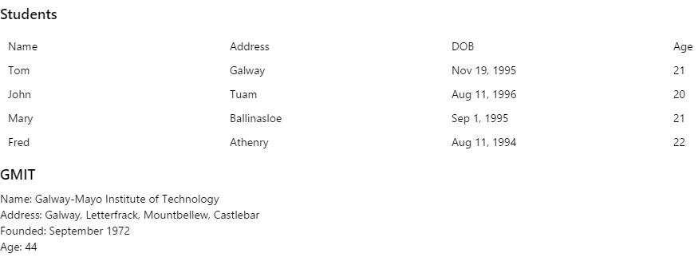

1. Write an Ionic Application that uses a Service to get a list of U.S. presidents from the following site: <https://api.myjson.com/bins/po22>.

The details should be displayed as follows:

